Unit 2

Analog and Digital Signal
A signal is an electromagnetic or electrical current that carries data from one system or network to another. A signal is often a time-varying voltage that is also an electromagnetic wave carrying information, though it can take on other forms, such as current.
There are two main types of signals: analog and digital signals.

Analog Signal

An analog signal is time-varying and generally bound to a range (e.g. +12V to -12V), but there is an infinite number of values within that continuous range. An analog signal uses a given property of the medium to convey the signal’s information, such as electricity moving through a wire. In an electrical signal, the voltage, current, or frequency of the signal may be varied to represent the information. Analog signals are often calculated responses to changes in light, sound, temperature, position, pressure, or other physical phenomena.

When plotted on a voltage vs. time graph, an analog signal should produce a smooth and continuous curve. There should not be any discrete value changes (see Figure 1).
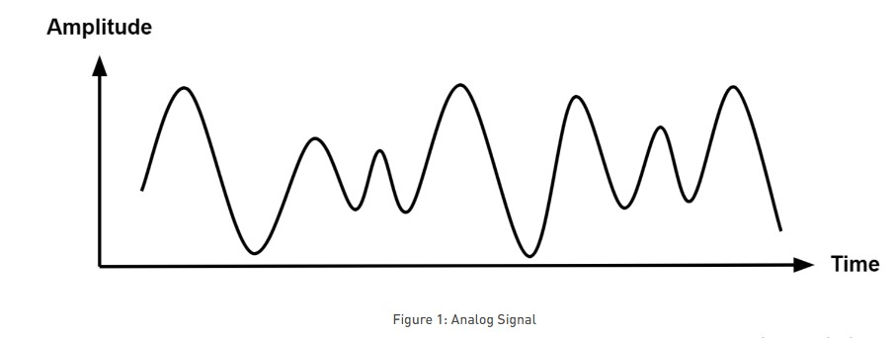
Digital Signal
A digital signal is a signal that represents data as a sequence of discrete values. A digital signal can only take on one value from a finite set of possible values at a given time. With digital signals, the physical quantity representing the information can be many things:
- Variable electric current or voltage
- Phase or polarization of an electromagnetic field
- Acoustic pressure
- The magnetization of a magnetic storage media
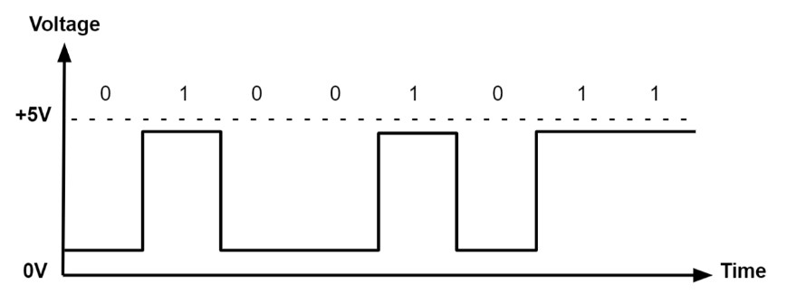

Analog versus Digital Signal
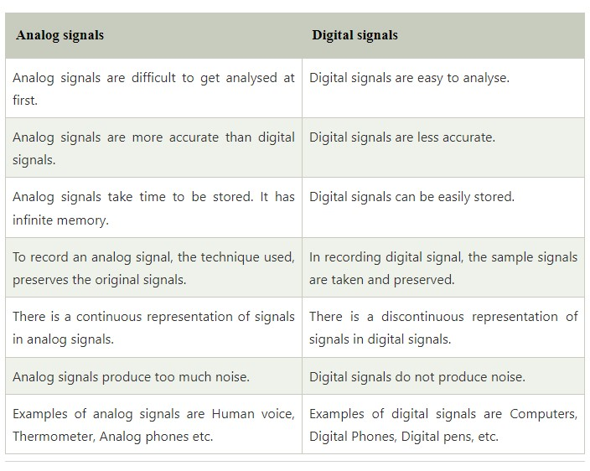

Data Rate Limits
Data rate refers to the speed of data transfer through a channel. It is generally computed in bits per second (bps). Higher data rates are expressed as Kbps ("Kilo" bits per second, i.e.1000 bps), Mbps ("Mega" bits per second, i.e.1000 Kbps), Gbps ("Giga" bits per second, i.e. 1000 Mbps) and Tbps ("Tera" bits per second, i.e. 1000 Gbps).

One of the main objectives of data communications is to increase the data rate. There are three factors that determine the data rate of a channel:
Bandwidth of the channel
Number of levels of signals that are used
Noise present in the channel

Digital to Digital Line Coding Schemes
The process of converting the digital data into digital signal is called as line coding which helps the receiver to get the original bits. The data that is in the form of text, numbers, audio, or video is represented internally as series of 1s and 0s. Line coding therefore transforms a set of bits into a digital signal. The sender side encrypts digital data into digital signals, while the receiving side decodes the digital signal to regenerate the digital data. The primary goal of utilizing line coding is to prevent the overlapping of pulses and distortions. The digital signal is discreet in nature. Example is sending data from computer to printer.
There are basically three different types of line coding technique:
- Unipolar
- Polar
- Bipolar

Unipolar
In Unipolar encoding, only one polarity is used i.e., bit 1 is used to represent positive voltage and bit 0 is used to represent zero voltage or idle line. It is also known as Unipolar-Non-return-to-zero. Signaling of this kind is also referred to as on-off signaling.
Problem in Unipolar
- DC Component: When we find out the average amplitude of a unipolar signal, then the value would always be non-zero because of which it creates DC component. And the signal having DC component is not able to travel through the medium which cannot handle DC component.
- Synchronization: When a signal is constant, the receiver cannot distinguish between the start and finish of each bit. For that the receiver has to rely on a timer to track the starting of each bit.
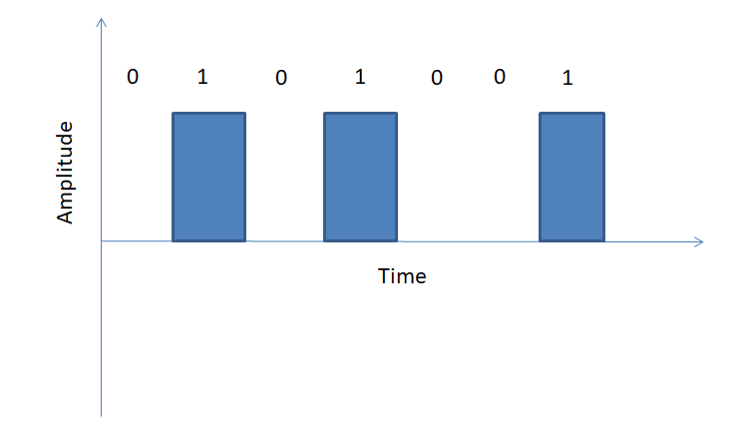
Unipolar encoding

Polar
The polar encoding is of four types. In polar encoding two levels of voltage amplitude is used. The DC component issue of unipolar encoding is minimized, and the average voltage level on the line is decreased.
- Polar Non-Return to Zero (Polar NRZ): In polar encoding, positive voltage is represented by bit 1 and negative voltage is represented by bit 0. Here two levels of voltage are used to represent binary values. If the line is idle, then there is no transition. With each inversion, the receiver is able to synchronize the timer’s start to the transmission’s real arrival. Again, Polar Non-Return to Zero (Polar NRZ) has two types: NRZ-L and NRZ-I.
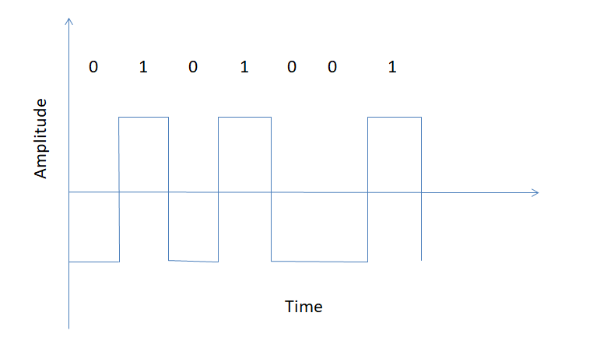
NRZ-L: Changes its voltage level when different bit is encountered.
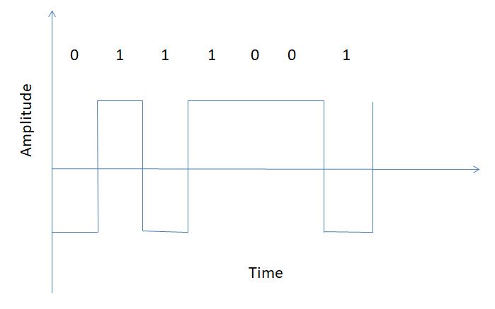
NRZ-I: Changes its voltage level when bit 1 is encountered.
Advantages of Polar NRZ
This provides synchronization as whenever a 1 bit is encountered, the signal changes.
- Return to Zero (RZ): This encoding technique uses three different voltage level to represent binary values. Bit 1 is used to represent positive voltage, bit 0 is used to represent negative voltage and zero voltage for none. During the second half of each bit, this signal enters a resting state(zero).
Problems in Return to Zero
This occupies more bandwidth as it requires two signal changes to encode one bit.
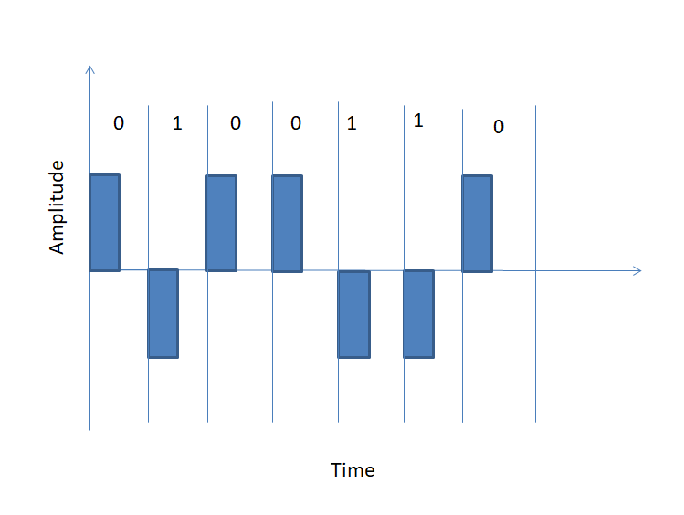
Return to Zero (RZ)
- Manchester Encoding: In Manchester encoding negative to positive transition represents binary 1 and positive to negative represents binary 0. Use the inversion at the middle of each bit interval. That means bit period is represented by two equal size intervals. Here the logic level of bit is represented by the first interval and the inverse logic level is represented by the second interval.
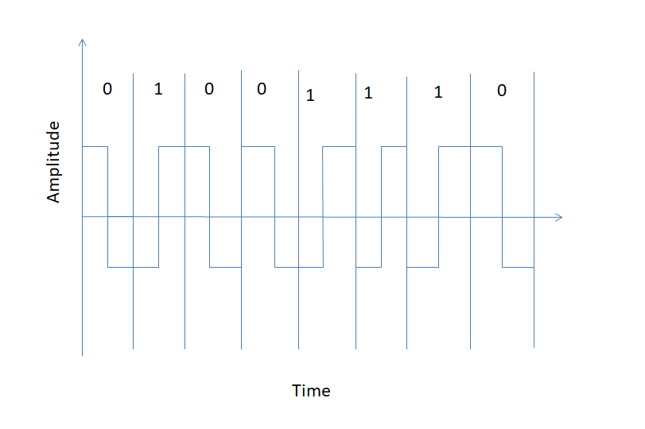
Manchester encoding
- Differential Manchester: In Differential Manchester, the inversion at the middle of the bit is used. Transition is represented by binary 0 and no transition is represented by binary 1.
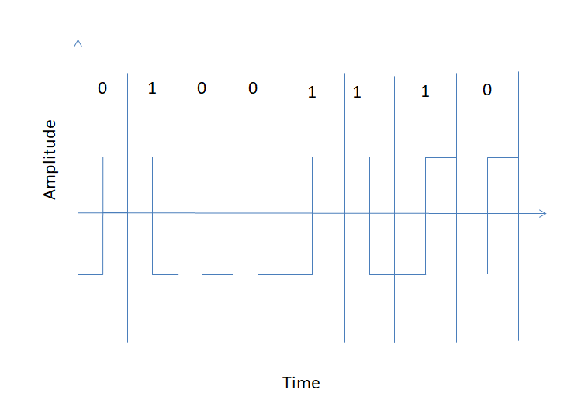
Different Manchester

Bipolar Encoding
In Bipolar encoding, three types of different voltage level is used that is positive, negative and zero. The zero level is used to represent binary 0, positive and negative voltage represents alternatives 1’s to prevent DC component. Alternate Mark Inversion (AMI) and Pseudoternary are the types of bipolar encoding.
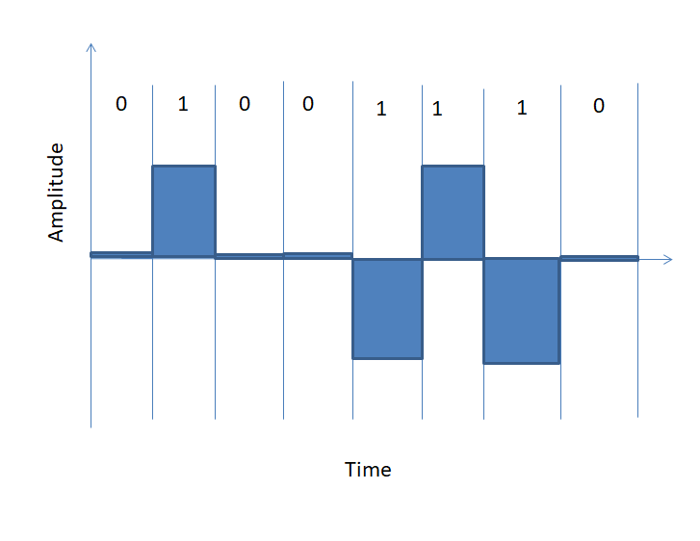
Bipolar Encoding

Table: Comparison of Different Digital-to-Digital Line Encoding Techniques
Line Encoding Technique | Description | Advantages | Disadvantages
Unipolar | Uses only one level of voltage for bit 0 and bit 1 | Easy to implement | DC component problem, synchronization issue
Polar NRZ | Uses two levels of voltage for bit 0 and bit 1, no transition for idle line | Provides synchronization, DC component issue minimized | May encounter problem with long sequences of 0’s or 1’s
RZ | Uses three levels of voltage for bit 0, bit 1 and idle line, signal enters resting state during second half of bit | Provides synchronization | Occupies more bandwidth
Manchester | Uses transition from positive to negative and negative to positive to represent bit 0 and bit 1 respectively, bit period represented by two equal intervals | Provides synchronization, self-clocking | Occupies more bandwidth
Differential Manchester | Uses transition at the middle of the bit interval to represent bit 0, no transition for bit 1, bit period represented by two equal intervals | Provides synchronization, self-clocking | More complex encoding and decoding process
Bipolar | Uses three levels of voltage for bit 0, bit 1 and idle line, alternative 1’s to prevent DC component | Provides synchronization, no DC component | More complex encoding and decoding process

Analog to Digital Conversion
When an analog signal is digitalized, that is known as analog-to-digital conversion.
Consider a human address a voice in the structure of an analog signal. We require to digitalize the analog signal that is smaller inclined to noise. It needed a decrease in the several values in an analog message defined in the digital flow.
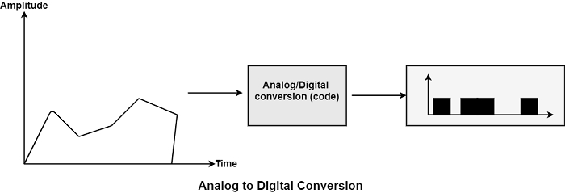
In analog-to-digital conversion, the data involved in a constant waveform is modified into digital pulses.

Methods for Analog-To-Digital Conversion
The various methods for Analog-to-Digital conversion are as follows −

PAM
The first phase in analog to digital conversion is known as PAM. PAM represents pulse amplitude modulation. This method creates an analog signal, samples it, and creates digital pulses sequences based on sampling. The sampling method used in PAM is more helpful to other manufacturing fields than data communication. PAM is the infrastructure of an essential analog-to-digital conversion method known as pulse code modulation (PCM).
In PAM, the initial signal is sampled at the same intervals, as display in the figure. PAM uses a method known as a sample and hold.
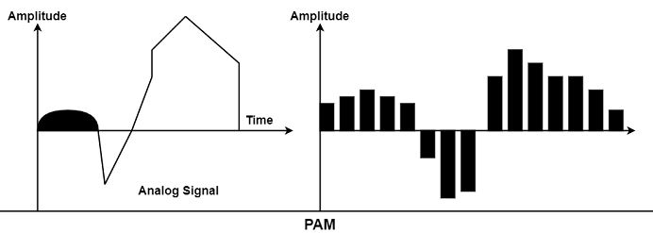

PCM
PCM represents Pulse Code Modulation. PCM method can change the pulses generated by PAM to develop a completely digital signal. To manage this, PCM first measures the PAM pulses. Quantization is a technique of authorizing integral values in a particular area to sampled instances. The outcome of quantization is shown in the figure.
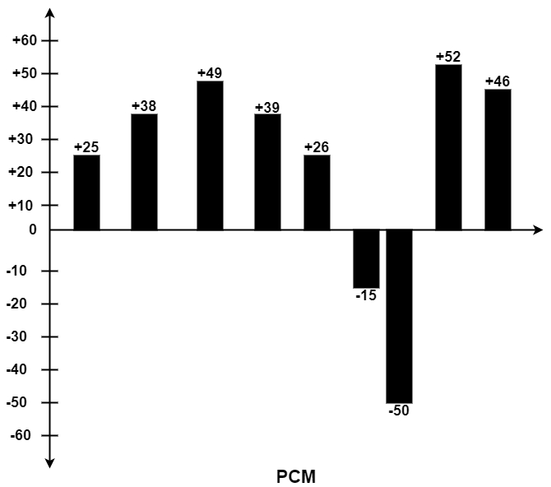
The figure displays a simple method of creating sign and magnitude costs to quantized samples. Each cost is interpreted into a six-bit binary proportionate. The seventh bit denoted the sign.
Quantizing using sign and magnitude.
+25 0011001 +39 0100111 -50 1110010
+38 0100110 +26 0011010 +52 0110100
+49 0110001 -15 1001111 +46 0101110
Where sign bit for + is 0 and for – is 1.

Sampling Rate
As shown in the previous figure, the efficiency of any digital recreation of an analog signal depends on the several samples taken. Using PAM and PCM, we can recreate the waveform precisely by creating infinite samples, or we can make the barest generalization of its direction of change by creating three samples of +24, +48, and +50.
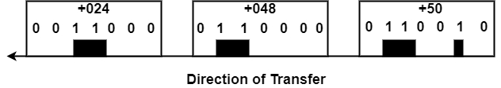
From analog signal to PCM digital code −
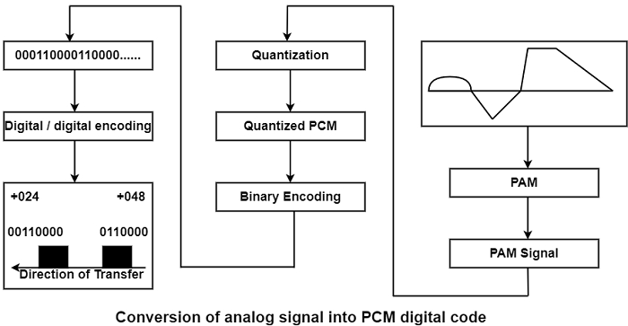
Example 1 − What sampling rate is required for a signal with a bandwidth of 9000 Hz (1000 to 10,000 Hz)?
Solution
The sampling rate should be trice the largest frequency in the signal −
Sampling rate = 2 (10, 000) = 20, 000 sample/seconds.
How many Bits per sample?
After discovering the sampling rate, we need to determine the number of bits to be transmitted for each sample. This is based on the method of precision required. The number of a bite are selected, including the original signal can be recreated with the desired accuracy in amplitude.
Bit Rate − After discovering several bits per sample, we can evaluate the bit rate using the following formula −
Bit rate = Sampling Rate x Number of bits per sample
Example 2 − We require to digitize the human voice. What is the bit rate considering eight bits per sample?
Solution
The human voice includes frequencies typically from 0 to 4000 Hz. So the sampling rate is −
Sampling Rate = 4000 x 2 = 8,000 samples/second
The bit rate can be calculated as given below −
Bit rate = Sampling rate x Number of bits per sample
Bit rate = 8000 x 8 = 64,000 bits/s = 64 Kbp

Analog to Digital Conversion
Digital Signal – A digital signal is a signal that represents data as a sequence of discrete values; at any given time it can only take on one of a finite number of values.
Analog Signal – An analog signal is any continuous signal for which the time varying feature of the signal is a representation of some other time varying quantity i.e., analogous to another time varying signal.
The following techniques can be used for Digital to Analog Conversion:
1. Amplitude Shift keying – Amplitude Shift Keying is a technique in which carrier signal is analog and data to be modulated is digital. The amplitude of analog carrier signal is modified to reflect binary data.
The binary signal when modulated gives a zero value when the binary data represents 0 while gives the carrier output when data is 1. The frequency and phase of the carrier signal remain constant.
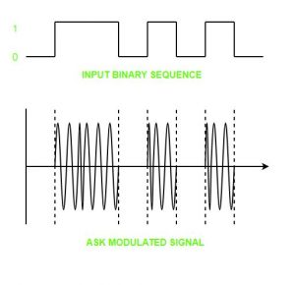
Advantages of amplitude shift Keying –
- It can be used to transmit digital data over optical fiber.
- The receiver and transmitter have a simple design which also makes it comparatively inexpensive.
- It uses lesser bandwidth as compared to FSK thus it offers high bandwidth efficiency.
Disadvantages of amplitude shift Keying –
- It is susceptible to noise interference and entire transmissions could be lost due to this.
- It has lower power efficiency.
2. Frequency Shift keying – In this modulation the frequency of analog carrier signal is modified to reflect binary data.
The output of a frequency shift keying modulated wave is high in frequency for a binary high input and is low in frequency for a binary low input. The amplitude and phase of the carrier signal remain constant.
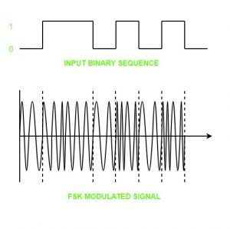
Advantages of frequency shift Keying –
- Frequency shift keying modulated signal can help avoid the noise problems beset by ASK.
- It has lower chances of an error.
- It provides high signal to noise ratio.
- The transmitter and receiver implementations are simple for low data rate application.
Disadvantages of frequency shift Keying –
- It uses larger bandwidth as compared to ASK thus it offers less bandwidth efficiency.
- It has lower power efficiency.
3. Phase Shift keying – In this modulation the phase of the analog carrier signal is modified to reflect binary data.The amplitude and frequency of the carrier signal remains constant.
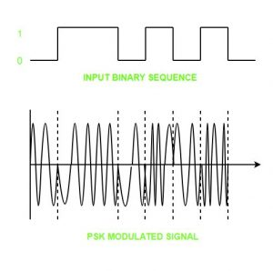
It is further categorized as follows:
- Binary Phase Shift Keying (BPSK):
BPSK also known as phase reversal keying or 2PSK is the simplest form of phase shift keying. The Phase of the carrier wave is changed according to the two binary inputs. In Binary Phase shift keying, difference of 180 phase shift is used between binary 1 and binary 0.
This is regarded as the most robust digital modulation technique and is used for long distance wireless communication.
- Quadrature phase shift keying:
This technique is used to increase the bit rate i.e we can code two bits onto one single element. It uses four phases to encode two bits per symbol. QPSK uses phase shifts of multiples of 90 degrees.
It has double data rate carrying capacity compare to BPSK as two bits are mapped on each constellation points.
Advantages of phase shift Keying –
- It is a more power efficient modulation technique as compared to ASK and FSK.
- It has lower chances of an error.
- It allows data to be carried along a communication signal much more efficiently as compared to FSK.
Disadvantages of phase shift Keying –
- It offers low bandwidth efficiency.
- The detection and recovery algorithms of binary data is very complex.
- It is a non coherent reference signal.

Multiplexing
- The transmission medium is used to send the signal from sender to receiver. The medium can only have one signal at a time.
- If there are multiple signals to share one medium, then the medium must be divided in such a way that each signal is given some portion of the available bandwidth. For example: If there are 10 signals and bandwidth of medium is100 units, then the 10 unit is shared by each signal.
- When multiple signals share the common medium, there is a possibility of collision. Multiplexing concept is used to avoid such collision.
- Transmission services are very expensive.

History of Multiplexing
- Multiplexing technique is widely used in telecommunications in which several telephone calls are carried through a single wire.
- Multiplexing originated in telegraphy in the early 1870s and is now widely used in communication.
- George Owen Squier developed the telephone carrier multiplexing in 1910.

Concept of Multiplexing
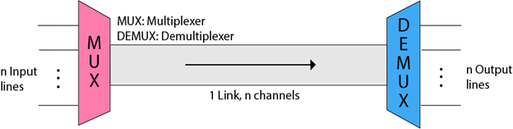
- The 'n' input lines are transmitted through a multiplexer and multiplexer combines the signals to form a composite signal.
- The composite signal is passed through a Demultiplexer and demultiplexer separates a signal to component signals and transfers them to their respective destinations.

Advantages of Multiplexing:
- More than one signal can be sent over a single medium.
- The bandwidth of a medium can be utilized effectively.

Multiplexing Techniques
Multiplexing techniques can be classified as:
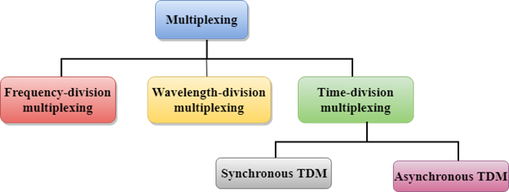

Frequency-division Multiplexing (FDM)
- It is an analog technique.
- Frequency Division Multiplexing is a technique in which the available bandwidth of a single transmission medium is subdivided into several channels.
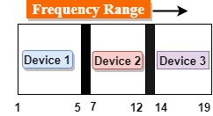
- In the above diagram, a single transmission medium is subdivided into several frequency channels, and each frequency channel is given to different devices. Device 1 has a frequency channel of range from 1 to 5.
- The input signals are translated into frequency bands by using modulation techniques, and they are combined by a multiplexer to form a composite signal.
- The main aim of the FDM is to subdivide the available bandwidth into different frequency channels and allocate them to different devices.
- Using the modulation technique, the input signals are transmitted into frequency bands and then combined to form a composite signal.
- The carriers which are used for modulating the signals are known as sub-carriers. They are represented as f1,f2..fn.
- FDM is mainly used in radio broadcasts and TV networks.
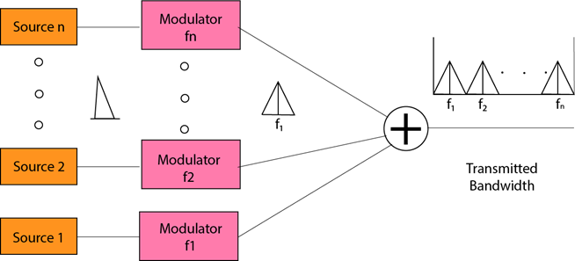
Advantages Of FDM:
- FDM is used for analog signals.
- FDM process is very simple and easy modulation.
- A Large number of signals can be sent through an FDM simultaneously.
- It does not require any synchronization between sender and receiver.
Disadvantages Of FDM:
- FDM technique is used only when low-speed channels are required.
- It suffers the problem of crosstalk.
- A Large number of modulators are required.
- It requires a high bandwidth channel.
Applications Of FDM:
- FDM is commonly used in TV networks.
- It is used in FM and AM broadcasting. Each FM radio station has different frequencies, and they are multiplexed to form a composite signal. The multiplexed signal is transmitted in the air.
Wavelength Division Multiplexing (WDM)
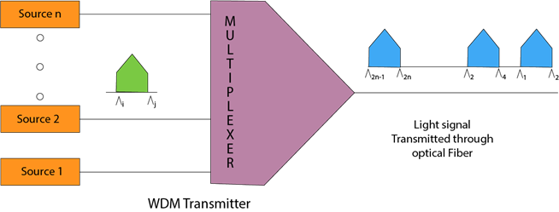
- Wavelength Division Multiplexing is same as FDM except that the optical signals are transmitted through the fibre optic cable.
- WDM is used on fibre optics to increase the capacity of a single fibre.
- It is used to utilize the high data rate capability of fibre optic cable.
- It is an analog multiplexing technique.
- Optical signals from different source are combined to form a wider band of light with the help of multiplexer.
- At the receiving end, demultiplexer separates the signals to transmit them to their respective destinations.
- Multiplexing and Demultiplexing can be achieved by using a prism.
- Prism can perform a role of multiplexer by combining the various optical signals to form a composite signal, and the composite signal is transmitted through a fibre optical cable.
- Prism also performs a reverse operation, i.e., demultiplexing the signal.
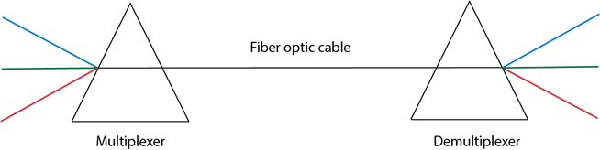

Time Division Multiplexing
- It is a digital technique.
- In Frequency Division Multiplexing Technique, all signals operate at the same time with different frequency, but in case of Time Division Multiplexing technique, all signals operate at the same frequency with different time.
- In Time Division Multiplexing technique, the total time available in the channel is distributed among different users. Therefore, each user is allocated with different time interval known as a Time slot at which data is to be transmitted by the sender.
- A user takes control of the channel for a fixed amount of time.
- In Time Division Multiplexing technique, data is not transmitted simultaneously rather the data is transmitted one-by-one.
- In TDM, the signal is transmitted in the form of frames. Frames contain a cycle of time slots in which each frame contains one or more slots dedicated to each user.
- It can be used to multiplex both digital and analog signals but mainly used to multiplex digital signals.
There are two types of TDM:
- Synchronous TDM
- Asynchronous TDM

Synchronous TDM
- A Synchronous TDM is a technique in which time slot is preassigned to every device.
- In Synchronous TDM, each device is given some time slot irrespective of the fact that the device contains the data or not.
- If the device does not have any data, then the slot will remain empty.
- In Synchronous TDM, signals are sent in the form of frames. Time slots are organized in the form of frames. If a device does not have data for a particular time slot, then the empty slot will be transmitted.
- The most popular Synchronous TDM are T-1 multiplexing, ISDN multiplexing, and SONET multiplexing.
- If there are n devices, then there are n slots.
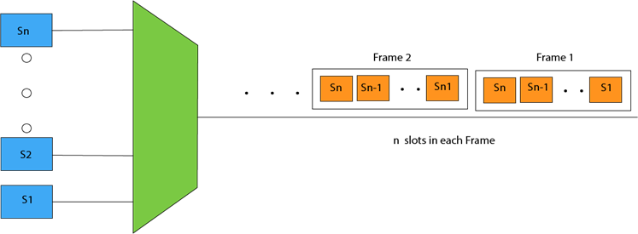
Concept Of Synchronous TDM
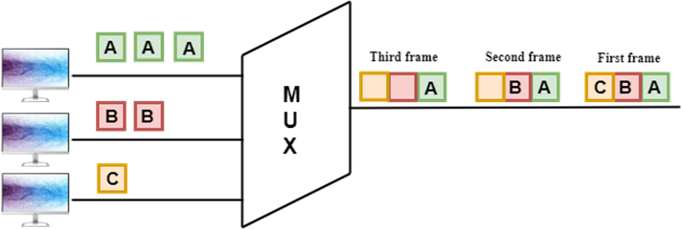
In the above figure, the Synchronous TDM technique is implemented. Each device is allocated with some time slot. The time slots are transmitted irrespective of whether the sender has data to send or not.
Disadvantages Of Synchronous TDM:
- The capacity of the channel is not fully utilized as the empty slots are also transmitted which is having no data. In the above figure, the first frame is completely filled, but in the last two frames, some slots are empty. Therefore, we can say that the capacity of the channel is not utilized efficiently.
- The speed of the transmission medium should be greater than the total speed of the input lines. An alternative approach to the Synchronous TDM is Asynchronous Time Division Multiplexing.

Asynchronous TDM
- An asynchronous TDM is also known as Statistical TDM.
- An asynchronous TDM is a technique in which time slots are not fixed as in the case of Synchronous TDM. Time slots are allocated to only those devices which have the data to send. Therefore, we can say that Asynchronous Time Division multiplexor transmits only the data from active workstations.
- An asynchronous TDM technique dynamically allocates the time slots to the devices.
- In Asynchronous TDM, total speed of the input lines can be greater than the capacity of the channel.
- Asynchronous Time Division multiplexor accepts the incoming data streams and creates a frame that contains only data with no empty slots.
- In Asynchronous TDM, each slot contains an address part that identifies the source of the data.
- The difference between Asynchronous TDM and Synchronous TDM is that many slots in Synchronous TDM are unutilized, but in Asynchronous TDM, slots are fully utilized. This leads to the smaller transmission time and efficient utilization of the capacity of the channel.
- In Synchronous TDM, if there are n sending devices, then there are n time slots. In Asynchronous TDM, if there are n sending devices, then there are m time slots where m is less than n (m<n).
- The number of slots in a frame depends on the statistical analysis of the number of input lines.
Concept Of Asynchronous TDM
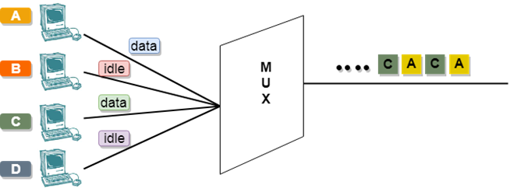
In the above diagram, there are 4 devices, but only two devices are sending the data, i.e., A and C. Therefore, the data of A and C are only transmitted through the transmission line.
Frame of above diagram can be represented as:
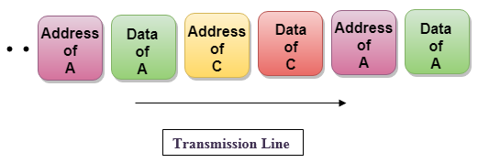
Transmission Media
- Transmission media is a communication channel that carries the information from the sender to the receiver. Data is transmitted through the electromagnetic signals.
- The main functionality of the transmission media is to carry the information in the form of bits through LAN(Local Area Network).
- It is a physical path between transmitter and receiver in data communication.
- In a copper-based network, the bits in the form of electrical signals.
- In a fibre based network, the bits in the form of light pulses.
- In OSI(Open System Interconnection) phase, transmission media supports the Layer 1. Therefore, it is considered to be as a Layer 1 component.
- The electrical signals can be sent through the copper wire, fibre optics, atmosphere, water, and vacuum.
- The characteristics and quality of data transmission are determined by the characteristics of medium and signal.
- Transmission media is of two types are wired media and wireless media. In wired media, medium characteristics are more important whereas, in wireless media, signal characteristics are more important.
- Different transmission media have different properties such as bandwidth, delay, cost and ease of installation and maintenance.
- The transmission media is available in the lowest layer of the OSI reference model, i.e., Physical layer.

Some factors need to be considered for designing the transmission media:
- Bandwidth: All the factors are remaining constant, the greater the bandwidth of a medium, the higher the data transmission rate of a signal.
- Transmission impairment: When the received signal is not identical to the transmitted one due to the transmission impairment. The quality of the signals will get destroyed due to transmission impairment.
- Interference: An interference is defined as the process of disrupting a signal when it travels over a communication medium on the addition of some unwanted signal.

Causes Of Transmission Impairment:
- Attenuation: Attenuation means the loss of energy, i.e., the strength of the signal decreases with increasing the distance which causes the loss of energy.
- Distortion: Distortion occurs when there is a change in the shape of the signal. This type of distortion is examined from different signals having different frequencies. Each frequency component has its own propagation speed, so they reach at a different time which leads to the delay distortion.
- Noise: When data is travelled over a transmission medium, some unwanted signal is added to it which creates the noise.

Classification Of Transmission Media:
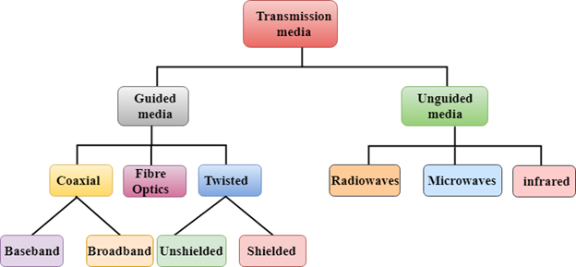
- Guided Transmission Media
- UnGuided Transmission Media

Guided Media
It is defined as the physical medium through which the signals are transmitted. It is also known as Bounded media.
Types Of Guided media:

Twisted pair:
Twisted pair is a physical media made up of a pair of cables twisted with each other. A twisted pair cable is cheap as compared to other transmission media. Installation of the twisted pair cable is easy, and it is a lightweight cable. The frequency range for twisted pair cable is from 0 to 3.5KHz.
A twisted pair consists of two insulated copper wires arranged in a regular spiral pattern.
The degree of reduction in noise interference is determined by the number of turns per foot. Increasing the number of turns per foot decreases noise interference.
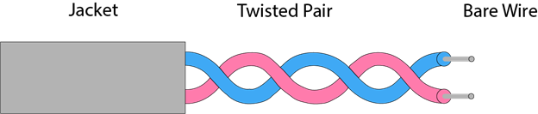
Types of Twisted pair:
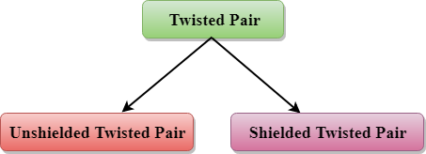

Unshielded Twisted Pair:
An unshielded twisted pair is widely used in telecommunication. Following are the categories of the unshielded twisted pair cable:
- Category 1: Category 1 is used for telephone lines that have low-speed data.
- Category 2: It can support upto 4Mbps.
- Category 3: It can support upto 16Mbps.
- Category 4: It can support upto 20Mbps. Therefore, it can be used for long-distance communication.
- Category 5: It can support upto 200Mbps.
Advantages Of Unshielded Twisted Pair:
- It is cheap.
- Installation of the unshielded twisted pair is easy.
- It can be used for high-speed LAN.
Disadvantage:
- This cable can only be used for shorter distances because of attenuation.

Shielded Twisted Pair
A shielded twisted pair is a cable that contains the mesh surrounding the wire that allows the higher transmission rate.
Characteristics Of Shielded Twisted Pair:
- The cost of the shielded twisted pair cable is not very high and not very low.
- An installation of STP is easy.
- It has higher capacity as compared to unshielded twisted pair cable.
- It has a higher attenuation.
- It is shielded that provides the higher data transmission rate.
Disadvantages
- It is more expensive as compared to UTP and coaxial cable.
- It has a higher attenuation rate.

Coaxial Cable
- Coaxial cable is very commonly used transmission media, for example, TV wire is usually a coaxial cable.
- The name of the cable is coaxial as it contains two conductors parallel to each other.
- It has a higher frequency as compared to Twisted pair cable.
- The inner conductor of the coaxial cable is made up of copper, and the outer conductor is made up of copper mesh. The middle core is made up of non-conductive cover that separates the inner conductor from the outer conductor.
- The middle core is responsible for the data transferring whereas the copper mesh prevents from the EMI(Electromagnetic interference).
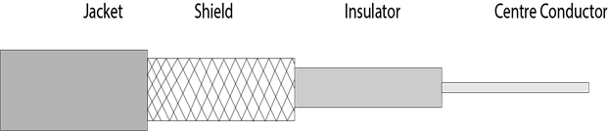
Coaxial cable is of two types:
- Baseband transmission: It is defined as the process of transmitting a single signal at high speed.
- Broadband transmission: It is defined as the process of transmitting multiple signals simultaneously.
Advantages Of Coaxial cable:
- The data can be transmitted at high speed.
- It has better shielding as compared to twisted pair cable.
- It provides higher bandwidth.
Disadvantages Of Coaxial cable:
- It is more expensive as compared to twisted pair cable.
- If any fault occurs in the cable causes the failure in the entire network.

Fibre Optic
- Fibre optic cable is a cable that uses electrical signals for communication.
- Fibre optic is a cable that holds the optical fibres coated in plastic that are used to send the data by pulses of light.
- The plastic coating protects the optical fibres from heat, cold, electromagnetic interference from other types of wiring.
- Fibre optics provide faster data transmission than copper wires.
Diagrammatic representation of fibre optic cable:
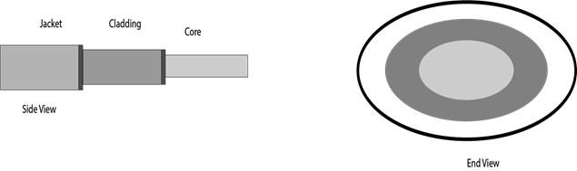
Basic elements of Fibre optic cable:
- Core: The optical fibre consists of a narrow strand of glass or plastic known as a core. A core is a light transmission area of the fibre. The more the area of the core, the more light will be transmitted into the fibre.
- Cladding: The concentric layer of glass is known as cladding. The main functionality of the cladding is to provide the lower refractive index at the core interface as to cause the reflection within the core so that the light waves are transmitted through the fibre.
- Jacket: The protective coating consisting of plastic is known as a jacket. The main purpose of a jacket is to preserve the fibre strength, absorb shock and extra fibre protection.
Following are the advantages of fibre optic cable over copper:
- Greater Bandwidth: The fibre optic cable provides more bandwidth as compared copper. Therefore, the fibre optic carries more data as compared to copper cable.
- Faster speed: Fibre optic cable carries the data in the form of light. This allows the fibre optic cable to carry the signals at a higher speed.
- Longer distances: The fibre optic cable carries the data at a longer distance as compared to copper cable.
- Better reliability: The fibre optic cable is more reliable than the copper cable as it is immune to any temperature changes while it can cause obstruct in the connectivity of copper cable.
- Thinner and Sturdier: Fibre optic cable is thinner and lighter in weight so it can withstand more pull pressure than copper cable.
Unguided Media
- An unguided transmission transmits the electromagnetic waves without using any physical medium. Therefore it is also known as wireless transmission.
- In unguided media, air is the media through which the electromagnetic energy can flow easily.
Unguided transmission is broadly classified into three categories:

Radio waves
- Radio waves are the electromagnetic waves that are transmitted in all the directions of free space.
- Radio waves are omnidirectional, i.e., the signals are propagated in all the directions.
- The range in frequencies of radio waves is from 3Khz to 1 khz.
- In the case of radio waves, the sending and receiving antenna are not aligned, i.e., the wave sent by the sending antenna can be received by any receiving antenna.
- An example of the radio wave is FM radio.
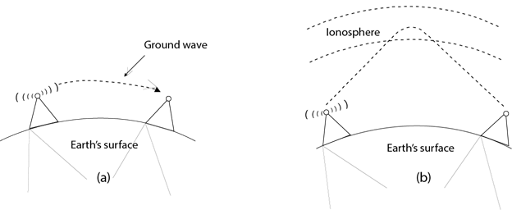
Applications Of Radio waves:
- A Radio wave is useful for multicasting when there is one sender and many receivers.
- An FM radio, television, cordless phones are examples of a radio wave.
Advantages Of Radio transmission:
- Radio transmission is mainly used for wide area networks and mobile cellular phones.
- Radio waves cover a large area, and they can penetrate the walls.
- Radio transmission provides a higher transmission rate.

Microwaves
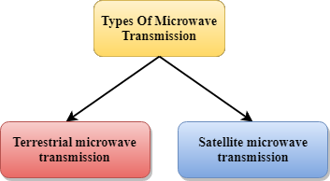
Microwaves are of two types:
- Terrestrial microwave
- Satellite microwave communication.

Terrestrial Microwave Transmission
- Terrestrial Microwave transmission is a technology that transmits the focused beam of a radio signal from one ground-based microwave transmission antenna to another.
- Microwaves are the electromagnetic waves having the frequency in the range from 1GHz to 1000 GHz.
- Microwaves are unidirectional as the sending and receiving antenna is to be aligned, i.e., the waves sent by the sending antenna are narrowly focussed.
- In this case, antennas are mounted on the towers to send a beam to another antenna which is km away.
- It works on the line of sight transmission, i.e., the antennas mounted on the towers are the direct sight of each other.
Characteristics of Microwave:
- Frequency range: The frequency range of terrestrial microwave is from 4-6 GHz to 21-23 GHz.
- Bandwidth: It supports the bandwidth from 1 to 10 Mbps.
- Short distance: It is inexpensive for short distance.
- Long distance: It is expensive as it requires a higher tower for a longer distance.
- Attenuation: Attenuation means loss of signal. It is affected by environmental conditions and antenna size.
Advantages Of Microwave:
- Microwave transmission is cheaper than using cables.
- It is free from land acquisition as it does not require any land for the installation of cables.
- Microwave transmission provides an easy communication in terrains as the installation of cable in terrain is quite a difficult task.
- Communication over oceans can be achieved by using microwave transmission.
Disadvantages of Microwave transmission:
- Eavesdropping: An eavesdropping creates insecure communication. Any malicious user can catch the signal in the air by using its own antenna.
- Out of phase signal: A signal can be moved out of phase by using microwave transmission.
- Susceptible to weather condition: A microwave transmission is susceptible to weather condition. This means that any environmental change such as rain, wind can distort the signal.
- Bandwidth limited: Allocation of bandwidth is limited in the case of microwave transmission.

Satellite Microwave Communication
- A satellite is a physical object that revolves around the earth at a known height.
- Satellite communication is more reliable nowadays as it offers more flexibility than cable and fibre optic systems.
- We can communicate with any point on the globe by using satellite communication.
How Does Satellite work?
The satellite accepts the signal that is transmitted from the earth station, and it amplifies the signal. The amplified signal is retransmitted to another earth station.
Advantages Of Satellite Microwave Communication:
- The coverage area of a satellite microwave is more than the terrestrial microwave.
- The transmission cost of the satellite is independent of the distance from the centre of the coverage area.
- Satellite communication is used in mobile and wireless communication applications.
- It is easy to install.
- It is used in a wide variety of applications such as weather forecasting, radio/TV signal broadcasting, mobile communication, etc.
Disadvantages Of Satellite Microwave Communication:
- Satellite designing and development requires more time and higher cost.
- The Satellite needs to be monitored and controlled on regular periods so that it remains in orbit.
- The life of the satellite is about 12-15 years. Due to this reason, another launch of the satellite has to be planned before it becomes non-functional.

Infrared
- An infrared transmission is a wireless technology used for communication over short ranges.
- The frequency of the infrared in the range from 300 GHz to 400 THz.
- It is used for short-range communication such as data transfer between two cell phones, TV remote operation, data transfer between a computer and cell phone resides in the same closed area.
Characteristics Of Infrared:
- It supports high bandwidth, and hence the data rate will be very high.
- Infrared waves cannot penetrate the walls. Therefore, the infrared communication in one room cannot be interrupted by the nearby rooms.
- An infrared communication provides better security with minimum interference.
- Infrared communication is unreliable outside the building because the sun rays will interfere with the infrared waves.

